**Title:** *Continued short-interval fires continue to transform boreal forests beyond modeled simple conifer to deciduous transitions*

**Abstract:**

Warming temperatures in the boreal have increased the frequency and severity of wildfires, causing time intervals between fires in areas to decrease to 10-15 years within the last several decades. Shortening fire intervals drive changes in successional pathways in boreal forests, but the extent of those changes and the interaction between topography and fire remains unclear. While postfire succession in upland boreal black spruce forests is well understood, the effect of varying topography on the impact of multiple short-interval fires remains unclear. To investigate how landscape variability alters postfire successional trajectories under shortening fire intervals, we established 50 plots across a mosaic of fire histories (1-3 fires in 70 years) in two Interior Alaska sites with differing hydrology. We compared regeneration of conifers, deciduous trees/shrubs, and graminoids in an upland site (drier) and a lowland site (wetter). All stands were originally dominated by black spruce (*Picea mariana*), and at both sites, black spruce regeneration was significantly lower following three fires, compared to unburned stands and stands burned once. In the wetter lowland site, less organic soil was consumed by fire and presence of black spruce persisted until two fires, indicating local topography may initially drive successional divergence via differences in substrate consumption. Deciduous regeneration differed between two sites after three fires, with Alaskan birch (*Betula neoalaskana*) dominating in upland plots and willow (*Salix spp.)* and aspen (*Populus tremuloides*) in lowlands. Results of this study offer strong empirical evidence of the divergence of boreal successional trajectories from previous historic norms and indicate the importance of examining the role of spatial heterogeneity on the impact of multiple disturbances.

**I. Introduction**

Warming temperatures have been linked with global increases in the frequency and intensity of wildfires, sparking concern that changing fire regimes will cause rapid ecosystem-level change if local resilience is exceeded (Young et al. 2017). Fire-free intervals in boreal systems have shrunk, and modern fire frequency in Interior Alaska is higher than any point in the last three thousand years (Kelly et al. 2013). Fire return intervals of < 20 years have increased across the last six decades, raising concerns that shortening fire intervals may disrupt or override historic successional trajectories entirely (Kasischke et al. 2010, Brown & Johnstone et al. 2012, Johnstone & Chapin 2006a, Johnstone & Chapin 2006b, Mann et al. 2012).

Fire is the primary initiator of secondary succession in boreal systems, and self-replacement is the most prevalent post-fire secondary successional pathway (Kurkowski et al. 2008). Black spruce (*Picea mariana*) typically self-replaces via large canopy seedbanks after fire, remaining the dominant canopy cover before and after disturbance, enabled by its semi-serotinous regeneration strategy (Kurkowski et al. 2008, Johnstone et al. 2004, Johnstone et al. 2010). By enabling dense regeneration within 10 years after fire, *P. mariana*’s serotinous strategy allows the species to maintain ongoing and persistent canopy coverage under historic fire return intervals (Johnstone et al. 2010). However, serotinous regeneration strategies are more vulnerable under increasing short-interval fires in boreal and other systems: short interval fires can consume local serotinous seedbanks, extirpating local populations, allowing for rapid forest type conversion (Buma et al. 2014). In the boreal specifically, the consumption of *P. mariana* seedbanks via short fire intervals allows for an increase in deciduous trees and shrubs (Brown and Johnstone 2012). Theoretical model outputs suggest that an increase in area reburned in short intervals will disfavor serotinous regeneration to the point of landscape-scale forest type conversion, leading to a shift in forest community composition from conifer-dominated stands to deciduous shrublands and grasslands (Johnstone et al. 2009, Hoy et al. 2016, Roland et al. 2019, Mann et al. 2012).

Rapid changes in fire characteristics impact successional drivers beyond the direct depletion of seedbanks: short interval fires further alter successional pathways through substrate consumption, disadvantaging local *P. mariana* populations (Brown & Johnstone 2012, Johnstone et al. 2004, Hollingsworth et al. 2013, Johnstone & Chapin 2006a, Johnstone et al. 2009). Burn severity promotes deciduous dominance by consuming the deep soil organic layers common in mature *P. mariana* boreal forests, favoring deciduous regeneration (Whitman et al. 2018). *P. mariana* has larger seeds than deciduous species like *P. tremuloides* and *B. neoalaskana*, allowing seeds to withstand time spent in dry surface organic layers (Greene et al. 2007, Johnstone and Chapin 2006). Removal of soil organic layers by severe fire negates the establishment advantage of *P. mariana* seeds: *B. neoalaskana* and *P. tremuloides* in particular produce large quantities of small wind-borne seeds, allowing those species to benefit from increased mineral seedbed after high-severity fire (Roland et al. 2013, Barrett et al. 2016, Johnstone et al. 2010A). Increasing frequency of high severity fires may further change conditions of competitive establishment in favor of deciduous species, cementing the possibility of rapid ecological change in the boreal.

Signs indicate the species-replacement post-fire successional pathway has already become more common: the transition of dominance from *P. mariana* to *B. neoalaskana* and other deciduous species following two consecutive fires has been well documented in Interior Alaska (Johnstone et al. 2004), the Yukon Territory (Brown et al. 2015, Whitman et al. 2018), Eastern Canada (Bergeron et al. 2012) and Northern Minnesota (Camill & Clark 2000, Frelich et al. 2017). This empirical work has emphasized the importance of reburning consuming serotinous seedbanks in particular, thereby limiting serotinous regeneration within the first 5-10 years postfire.

Furthermore, the effect of single reburns in black spruce stands is well documented in boreal Interior Alaska, but primarily in gently sloped upland environments typical in the Interior (Gibson et al. 2016, Houle et al. 2017). Successional trends in flatter, wetter lowland sites remain underexamined, though they represent 42% of the boreal Interior area (Douglas et al. 2014, Jorgensen and Shur 2007). The under-examination of lowlands in comparison to upland sites may be in part because of the historic unlikelihood of lowlands burning (Le Goff and Sirois 2004, Whitman et al. 2019). Given warming temperatures, lowland sites may begin burning more frequently, making it crucial to understand postfire successional trajectories in lowland sites, particularly if lowlands may be more resistant to the effects of shortening fire intervals. Soil moisture may have an important role in mediating the effects of fire on successional pathways in wetter lowland sites, providing a potential mechanism of resilience for black spruce stands (Houle et al. 2017).

To date, research has been limited to single reburn events (2 fires in sequence) in coniferous systems. While this is valuable, an increase in fire frequency means repeated multiple short interval events and reburning in non-coniferous systems. The cumulative effects of three or more fires remains unknown, limiting our ability to make inferences regarding future boreal forest community composition. Furthermore, research on short interval fires has almost entirely focused on conifer resilience, but the effects of short interval fires on deciduous species is unknown. Given the increasing evidence that reburning leads to stands dominated by deciduous trees and shrubs , understanding the effects of multiple fires on the emerging deciduous-dominated forest structure will be essential to understanding and predicting the impact of ongoing environmental and climatic change in high-latitude environments.

This study characterizes post-fire regeneration of tree species across a gradient of 1-3 fires in both upland and lowland forests, which followed a rapid increase in fire frequency from the 1940s to present We hypothesize that repeat, short interval fires will reduce conifer abundance via a reduction in the seedbank and organic layer thickness, favoring deciduous trees, as shown in other systems and studies. We anticipate that plots in the dry, sloped upland site may be less resistant to this transition due to lower organic soil levels after each fire. Furthermore, we hypothesize that repeat burning in deciduous stands will cement successional trends in favor of broadleaf species. We test those hypotheses by A) comparing patterns of postfire regeneration of tree occupancy, abundance and recruitment across a range of fire histories within a single pre-fire forest type in upland and lowland sites and by B) linking topographic and edaphic characteristics to occupancy, abundance and recruitment patterns of tree regeneration by species in both sites.

**II. Methods**

The study region is in boreal interior Alaska. F

Mature *P. mariana* stands dominate the ecoregion, characterized by dense stand structure and thick, moss-capped organic layers. Occasional *B. neoalaskana* and *Salix* species occur typically in the understory. In typical intermediate or long fire free intervals, either black spruce immediately self-replaces after fire or herbs and *Salix* shrubs establish before being replaced by *B. neoalaskana* and *P. tremuloides, which are* eventually overtaken by *P. mariana* (Johnstone et al. 2004). If there is a very short period between fires (e.g., <30 years), *P. mariana* populations are often extirpated as a result of seed-bank loss/consumption of the immature seedligns/saplings (Kurkowski et al. 2008). Previous studies examining patterns of tree regeneration after single reburns have found that boreal successional pathways are typically discernable within two years after fires, and that the majority of boreal recruitment occurs within 13-10 years after fire (Ott et al. 2006, Johnstone et al. 2004).

**Figure 1. Map of Study Sites. [need to add scale bar]**

**Site Selection**

We established 50 individual 20x20m plots in the summers of 2018 and 2019 between an upland and lowland location in Interior Alaska in natural mosaics of *P. mariana* pre-fire forest types differing in recent fire history (Figure 1). Each plot experienced between one to three fires in the last 60 years, with the final burn in 2004, 2005 or 2006. Eight unburned plots were established as controls (total n=50).

*Site History*

All plots were dominated by *P. mariana* before the first fire with occasional individual *B. neoalaskana* or *Salix spp*. Presence of spruce prior to the burn sequence was established from historic aerial photographs (Supplement 1). We further ground-truthed species composition prior to previous fires by sampling downed woody debris consumed in previous events and identifying to species level via wood anatomy. Fire severity has a well-documented role in post-fire forest community composition in the boreal: to constrain for effects of severity, all plots experienced full canopy mortality during each fire, as identified by aerial photography and remotely sensed fire perimeters (Hollingsworth et al. 2013, Whitman et al. 2018). To verify, we aged snags to ensure no survivors from prior events. Time since fire was held constant to allow for temporally constrained comparison of postfire regeneration trends.

**Figure 2. Pictures of study sites. A) Unburned mature black spruce stand. B) Once-burned former black spruce stand, 15 years since last fire C) Twice-burned former black spruce stand, 15 years since last fire. D) Thrice-burned former black spruce stand, 16 years since last fire.**

Burn history was established based on both historic aerial photographs from XXX source, and modern remotely sensed fire perimeters from XX source. For the earliest fires, pre-fire composition and complete aboveground mortality at a plot was inferred via the historical photographs described above and verified via wood anatomy/tree ages where possible. We sampled plots representing four specific stages of reburn history: 1) mature unburned black spruce forest stands (Fig. 2A), 2) once-burned black spruce forest recovering from a single short-interval fire (~15 years ago, Fig. 2B), 3) twice-burned black spruce forest recovering from two short-interval fires (one ~ 30 years ago, and the second ~15 years ago, Fig. 2C), and 4) thrice-burned black spruce forest, burned once ~45 years ago, a second time ~30 years ago and finally a third ~15 years ago (Figure 2D). Time between fires was constrained to 10-15 years, and all plots last burned 15 to 16 years ago.

*Site Locations*

Plots were randomly placed within various burn histories, with a minimum of 50 meters spacing and a minimum of 50 meters away from unburned legacies. Plots were stratified evenly between an upland site and a lowland site. The upland site represents well drained boreal forest; the lowland a flatter, more poorly drained location. Both are on the northern edge of the discontinuous permafrost zone and nearby unburned black spruce communities have shallow permafrost in both locations (data not shown).

**Field Sampling**

For all individual trees above diameter at breast height (DBH or 1.37 meters), we recorded species, DBH, condition (live or dead), canopy health, presence of browse and corresponding understory species, identifying individuals either as saplings (DBH > 2.5 cm) or trees (< 2.5 cm). Where density precluded counting over the entire 400m2, a randomly selected subset (100 or 200 m2) was counted. We recorded presence, species and condition of seedlings that fell below 1.37 meters across ten 1-meter sections randomly placed on each plot. For asexual reproducers such as *Salix* and *P. tremuloides*, each individual stem in a given clump was counted and then clumps were pooled and treated as individuals.

To assess soil consumption in the most recent fire, distance from adventitious roots to current soil surface was measured where snags were available to sample. Current organic layer depth was measured at the center and at each corner of each plot. Presence and abundance of organic and inorganic substrate surfaces were estimated across 1-meter subplots at each corner of each site.

**Environmental / Topographic Covariates**

Need to list the data sources for the GIS stuff (topography, etc) and climate stuff

**Data Analysis**

To characterize patterns in post-fire tree regeneration according to reburn history, we examined patterns in 3 metrics of regeneration amongst species of trees, saplings and seedings: 1) occupancy, defined here as the relative presence or proportion of species within a plot, 2) density (number of stems per hectare), and 3) abundance, measured via basal area (square centimeters per hectare). Differences in tree regeneration patterns across reburn history and between site type were evaluated using Welch two-sample t-tests.

Linear mixed effect models (LME) were used to evaluate the relative role of site attributes and substrate consumption in driving tree regeneration patterns. Fixed effects included site attributes: slope, solar radiation, elevation, average organic layer depth, and average exposed mineral soil. Site and site code were included as a random effect depending on model fit in order to capture site- or plot-level differences in fire effects or pre-fire conditions not captured in other variables. Number of fires was included as either a fixed effect or a random effect depending on model fit to acknowledge the possibility that the effects of fire history might vary according to site type. Overall model fit was evaluated using AIC, with the best model determined via XXX.

All analysis, model fit, and selection were performed in R version 1.2.1335 (R Development Core Team, 2018) and reported means include +/- 1 standard deviation. Generalized mixed models were conducted using ‘lme4’ (Bates et al. 2019). Figures were created through ‘ggplot2’ (Wickham 2016) and ‘cowplot’ (Wilkes et al. 2019). Because our plots are clustered by design to take advantage of natural experimental conditions, spatial autocorrelation among plots was assessed using Moran’s I. We found evidence of spatial autocorrelation within lowland plots (Table X) but accounted for the grouping of plots in sites by including site as a random effect in LMEs and allowing fire history to vary as a function of site.

**Table X. Results from Moran’s I for spatial autocorrelation in density (stem count per hectare) and basal area (square centimeters per hectare) of trees within upland and lowland sites.**

|  |  |  |  |  |  |
| --- | --- | --- | --- | --- | --- |
| Comparison | Variable | Observed | Expected | P-value | sd |
| Upland | Density | -0.02012 | -0.00775 | 0.026 | 0.005 |
| Basal Area | -0.02543 | -0.00775 | 0.001 | 0.005 |
| Lowland | Density | -0.00704 | -0.00598 | 0.7929 | 0.004 |
| Basal Area | -0.00788 | -0.00598 | 0.6434 | 0.004 |

**III. Results**

Our plots ranged in elevation from 245 m to 442 m above sea level and slope angles ranged from flat to 13 degrees. Upland plots receive an average of XX inches of rainfall per year, while lowland plots receive XX.

*Patterns in species occupancy: All (?) individuals*

Unburned plots in both sites were primarily occupied by mature *P. mariana* (uplands mean 87.9% +/- 5.1%, lowlands 97% +/- 2.9%) with occasional *B. neoalaskana* (upland 1.9% +/- 1.6%, lowland 0%) and *Salix* (upland plots 10.2% +/- 3.9%, lowland 1.47% +/- 1.9%). Once-burned plots between both sites contained *A. crispa* (1.6% +/- 3.4%), *B. neoalaskana* (8.7% +/- 12.4%), *P. mariana* (59.6% +/- 27.8%), *P. tremuloides* (1.5% +/- 3.1%) and *Salix* (28.6% +/- 18.3%) of all growth forms. Upland twice-burned plots were occupied by occasional small proportions of *A. crispa* (6.7% +/- 11.8%), *P. glauca* (3.9% +/- 10.9%) and *P. tremuloides* (4.5% +/- 9.8%) and predominantly occupied by *P. mariana* (22.3% +/-19.2%), *B. neoalaskana* (22.7% +/- 15.9%) and *Salix* (39.9% +/- 23%). Lowland twice-burned communities included low proportions of *A. crispa* (0.3% +/-0.6%), *B. neoalaskana* (4.2% +/- 1.4%) and *P. tremuloides* (6.3% +/- 3%) and tended to be predominantly occupied by *P. mariana* (33.3% +/- 12%) and *Salix* (55% +/- 12%). Finally, patterns in overall occupancy diverged between upland and lowland thrice-burned plots: *B. neoalaskana* and *Salix* were most present in upland plots (63% +/- 21% and 28.1% +/- 15.6% respectively), while lowland plots were most commonly occupied by high proportions of *P. tremuloides* and *Salix* (23.5% +/- 18.1% and 58% +/- 20.3%).

*Patterns in species occupancy: Current canopy individuals*

Individuals above DBH represent the first cohort of trees to establish after the most recent fire, meaning tree occupancy patterns reflect successful immediate postfire recruitment. 6 plots had no individuals large enough to qualify as trees (2 once-burned upland plots, 2 once-burned lowland plots, and 2 twice-burned lowland plots). Trends in tree presence diverged between upland and lowland plots: once-burned upland plots were predominantly occupied by *A. crispa* (14.4% +/- 11.6%) trees, followed in order of decreasing presence by *B. neoalaskana* (5.6 % +/- 7.7%), *Salix* (3.27% +/-5.3%) and *P. mariana* (1.6% +/- 2.7%). Meanwhile, once-burned lowland plots were predominantly occupied by *Salix* (10% +/- 13%) and *B. neoalaskana* (6.2% +/- 10.8%) and contained higher percentages of *P. mariana* (4% +/- 8.9%), *A. crispa* (3.5% +/- 5.5%) and *B glandulosa* (1.2% +/- 2.8%) than upland counterparts. B. neoalaskana were most present in twice-burned upland and lowland plots (15.5% +/- 6.2% and 12.5% +/- 10.2%)). *B. neoalaskana* trees were also most present in thrice-burned upland plots (12.5% +/- 8.9%), followed by only *Salix* (7.2% +/- 4.4%) and *A. crispa* (5.2% +/- 6.6%) trees. Thrice-burned lowland plots had a greater number of species present as trees: *P. tremuloides* trees were most present (12.2% +/- 7.8%), followed by *Salix* (10% +/- 6%), *B. neoalaskana* (1.6% +/- 1.6%), *B. glandulosa* (0.8% +/- 2.2%) and *P. baslsamifera* (0.21% +/- 0.6%).

The relative proportion of species present as saplings and seedlings serves as an indicator of subsequent cohort establishment and can reflect both trends in incoming recruitment and potential future community composition. Saplings represent the fastest growing individuals of incoming recruitment and can provide insight into species-level viability of future cohorts. Few saplings of any species other than *P. mariana* were present in unburned plots (%). *B. neoalaskana* was the most prevalent sapling in both once-burned upland and lowland plots (53.6% +/- 36.7 % and 68% +/- 113% respectively), while (describe whether upland or lowland). [describe saplings in twice-burned] [describle saplings in thrice-burned] Finally, proportions of seedling species present on a plot serve as an indicator of the presence and availability of local seed source and can help provide insight into trends of future community composition. *P. mariana* seedlings were most abundant in unburned plots in both the upland (86.7% +/-11.4%) and lowland site (98.2% +/- 3.5%), but presence declined with increasing fires to 2.2% (+/- 3.2%) and 4.9% (+/- 5.5%) in thrice-burned upland and lowland plots respectively. Deciduous seedling presence increased across fire history in both upland and lowland plots: upland plots saw increases in *B. neoalaskana* and *Salix* seedlings between one (), two () and three fires(), while lowland plots were characterized by increasing presence in *Salix* seedlings alongside a significant increase in *P. tremuloides* seedlings between twice and thrice burned plots (p-value).

**Figure X. Average proportion of all growth forms across species present at each burn history between upland and lowland plots. Error bars represent standard deviations.** 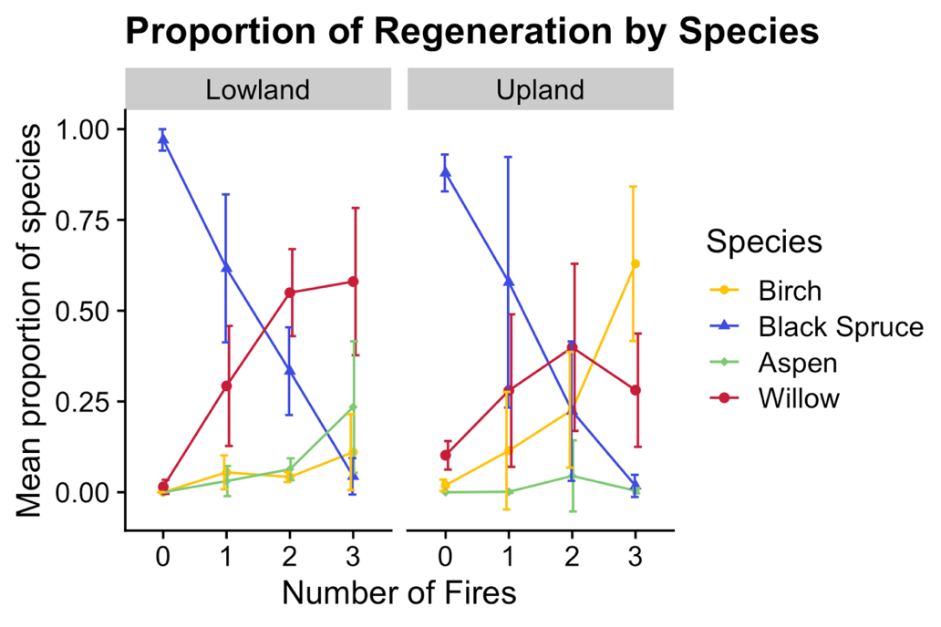

*Patterns in density*

Overall tree density was highest in unburned plots in both sites (mean 385.94 stems per ha +/- 913). Density of conifers in upland plots declined with reburn events from an average of 2687 (+/- 1249) stems/ha in unburned plots to 65 stems/ha (+/- 175) in once-burned plots, to 0 in both twice- and thrice-burned plots. Conifer density was lower overall in the lowland site: unburned plots had an average conifer density of 1694 stems/ha (+/-608), which declined to 28 stems/ha (+/- 75) in once-burned plots and then 0 stems/ha in twice- and thrice-burned plots.

Continued reburning lead to an overall increase in density of deciduous trees: upland unburned plots had an average deciduous density of 58 stems/ha (+/- 90), which increased to 66 stems/ha (+/- 176) in once-burned plots and then 122 (+/- 169) and 319 (+/- 814) in twice- and thrice-burned plots respectively. Patterns in deciduous tree density also diverged between upland and lowland plots: lowland unburned plots had an average deciduous density of 3 stems/ha (+/-8), increasing to 7 stems/ha (+/- 18) in once-burned plots, and then 6 (+/- 15) and 81 stems /ha (165) in twice- and thrice-burned plots.

*Patterns in abundance* **[Basal area graph]**

Overall tree abundance was highest in unburned sites (117 cm2/ha, +/- 294). Tree abundance and especially conifer tree abundance in unburned plots was significantly higher (p = 0.002) in the upland site than the lowland (average 1028 cm2/ha +/- 197and 279 cm2/ha +/- 74 respectively). Conifer tree abundance declines with continued reburning from 4 cm2/ha (+/- 10) and 8 cm2/ha (+/- 22) in once-burned upland and lowland plots respectively, to 0 cm2/ha in all twice- and thrice-burned plots. Similar to density, deciduous tree abundance increased with increasing fire

**Soil Consumption**

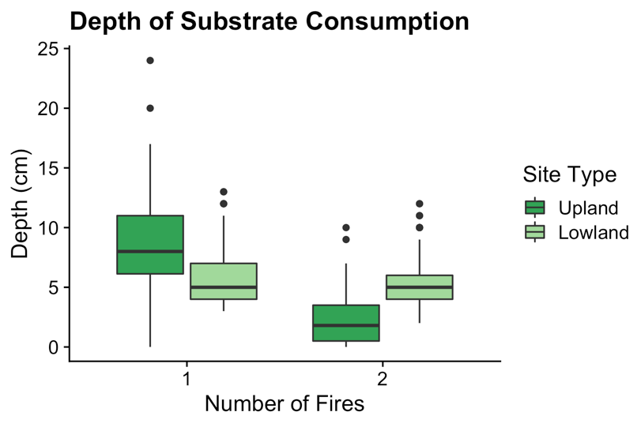

**Figure X. Distance in centimeters between highest adventitious *P. mariana* roots to soil surface across fire history.**

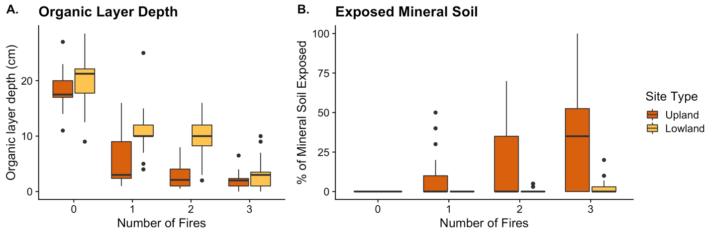

**Figure X. A) Depth of Organic Layer (cm) in Upland and Lowland plots according to burn history. B) Percent cover of exposed mineral soil in Upland and Lowland plots across burn history.**

Adventitious roots were only available to sample in once- and twice-burned plots, as three burn plots had no P. mariana to assess. Depth from adventitious root to current soil surface ranged from 0 to 24 cm in once-burned upland plots, and 3 to 7 cm in once-burned lowland plots. Average adventitious root depth in upland plots shrank between once- and twice-burned plots by a factor of 2.4. Adventitious root depth in lowland plots did not differ significantly (p-value = 0.11 between once-burned and twice-burned plots.

Lowland organic-layers were thicker than upland layers regardless of burn history by a factor of 1.6, and the difference between the two sites was largest in twice-burned plots where lowland organic-layers were larger by a factor of 3.2. The decline in organic layer depth occurs faster in upland plots than in lowland plots: organic layers were reduced by a factor of 3.2 after one fire in upland plots, but only by a factor of 1.8 in lowland plots. Organic layer depths do not become statistically similar between the two sites until three fires (p-value = 0.03). Similar trends exist for exposed mineral soil: upland plots had no exposed mineral soil in unburned plots but saw an increased in the amount of exposed mineral soil, up to 100% in some thrice-burned plots.

**Model Results**

*Density*

The effect of number of fires on densities of conifer trees and saplings varied as a function of site, while number of fires had a significant positive impact on deciduous trees and sapling densities. Increased average organic layer depth lead to increases in conifer sapling and tree densities but had no discernible effect on density of deciduous seedlings or saplings. An increase in average exposed mineral soil had a significant negative impact on deciduous densities (specify if this ends up just being saplings / trees).

*Abundance*

Fire history effects on abundance of both conifer and deciduous saplings differed as a function of site. Average organic layer depth increased conifer sapling abundance by 24 cm2/ha but had a slightly negative nonsignificant effect on deciduous sapling basal area. Site attributes of slope and solar radiation had significant positive effects on abundance of conifer trees, as did average organic layer depth and exposed mineral soil. An increase in average organic layer depth decreased deciduous tree basal area by 4.99 cm2/ha.

**Table X. Direction and significance of effect sizes of fire history, site attribute and fire effect variables on regeneration of conifer and deciduous seedlings, saplings and trees. Significance of effect indicated as follows: *** p ≤ 0.001, ** p ≤ 0.01, * p ≤ 0.05.**

**Table XA. Stem densities (stem count per hectare of saplings and trees, stem count per 400 m2 for seedlings)**

|  |  |  |  |  |  |  |  |
| --- | --- | --- | --- | --- | --- | --- | --- |
| Covariate | | **Saplings** | | **Trees** | | **Seedlings** | |
| *Conifer* | *Decid.* | *Conifer* | *Decid.* | *Conifer* | *Decid.* |
| **Number of Fires** | Random Effect | X |  | X |  |  |  |
| Fixed Effect |  | + 987.61 *** |  | + 270.03 *** | - 43978.25*** |  |
| **Site Attributes** | Slope |  | + 201.69 *** | + 6.39 | + 119.74 *** | - 5218.37* |  |
| Solar Radiation | + 0.02 |  |  |  | -34.77*** |  |
| Elevation |  |  |  |  | + 3248.84*** |  |
| **Fire Effects** | Av. OL Depth | + 92.44 *** |  | + 122.43 *** |  | -7150.05*** |  |
| Av. Exp. Mineral Soil | + 4.01 | -28.02** |  | - 13.31 *** | -653.26** |  |

**Table XC. Relative presence of conifers and deciduous individuals.**

|  |  |  |  |  |  |  |  |
| --- | --- | --- | --- | --- | --- | --- | --- |
| Covariate | | **Saplings** | | **Trees** | | **Seedlings** | |
| *Conifer* | *Decid* | *Conifer* | *Decid* | *Conifer* | *Decid* |
| **Number of Fires** | Random Effect |  | X | X | X |  |  |
| Fixed Effect | - 0.15 * |  |  |  |  |  |
| **Site attributes** | Slope |  |  | + 0.00 | - 0.00 |  |  |
| Solar Radiation |  |  |  |  |  |  |
| Elevation | + 0.01 ** | + 0.01 *** | + 0.00 |  |  |  |
| **Fire Effects** | Av. Organic Layer Depth | + 0.05 **\*\*** | - 0.21 *** | + 0.04 *** | - 0.04 *** |  |  |
| Av. Exposed Mineral Soil |  |  |  | - 0.00 |  |  |

**Table XB. Basal Area (square centimeters per hectare).**

|  |  |  |  |  |  |
| --- | --- | --- | --- | --- | --- |
| Covariate | | **Saplings** | | **Trees** | |
| *Conifer* | *Decid.* | *Conifer* | *Decid.* |
| **Number of Fires** | Random Effect | X | X | X |  |
| Fixed Effect |  |  |  | + 2.12 |
| **Site Attributes** | Slope |  |  | + 37.31 *** | + 5.67 |
| Solar Radiation |  | + 0.01 ** | + 0.12 *** |  |
| Elevation |  |  | - 12.19 *** | - 0.13 |
| **Fire Effects** | Av. OL Depth | + 24.00 **\*\*\*** | - 0.25 | + 37.34 *** | - 4.99* |
| Av. Exp. Mineral Soil | + 0.98 |  | + 2.66 *** |  |

**IV. Discussion**

A divergence in trends in tree occupation, density and abundance between upland and lowland sites indicates that site-level differences in drainage conditions and fire severity effects play an important role in determining successional outcomes in boreal Interior Alaska. In both sites in this study, deciduous communities emerged after multiple repeat short-interval fires, replacing original black spruce communities, but the composition, structure and regeneration of those communities differed according to site type. Upland reburned plots were composed of willow and birch in higher abundance and densities than comparable lowland plots and experienced a decline in black spruce earlier in the reburn sequence. Black spruce populations declined slower in lowland plots and were replaced by aspen and willow after three fires. in lower quantities than Upland counterparts. Results from linear mixed effect models indicate that post-fire substrate conditions play an important role in controlling post-fire tree occupation, density and basal area conditions Furthermore, model selection determined that the variable of number of fires varied as a function of site, indicating fire-level and site-level differences either directly or indirectly impact post-fire trends in recruitment, stand structure and basal area.

**[reflect on patterns of presence]**

**[reflect on patterns of density] –** Changes in stand density imply a change in stand structure, which has implications for landscape characteristics like aboveground carbon storage and landscape flammability. Given that fuel will play a central role in ongoing boreal fire regime change, understanding the influence of decreasing stand density on local fuel loads and structure will be crucial to managing and predicting future fire behavior in reburned stands (Higuera et al. 008).

**[reflect on patterns of abundance] –** Furthermore, an overall decline in basal area with increasing fire implies a similar decline in aboveground carbon stocks, particularly aboveground storage of carbon by trees.

[reflect on patterns of burn severity] - Upland plots had substantially thinner organic layers and significantly more exposed mineral soil than lowland equivalents. Given the role of burn severity in altering circumstances of competitive standing between coniferous and deciduous species, this variation between sites indicates that heterogeneity in hydrology via local topography may facilitate resilience or resistance in black spruce stands experiencing increasing short interval fires. Local soil moisture may act as a mechanism of resistance to short fire intervals only up until a given threshold of fire exposure, given that the organic layers in thrice-burned lowland plots did become statistically similar to those found in thrice-burned upland plots.

**V. Conclusion**

Observed trends in tree regeneration indicate a boreal forest successional trajectory untethered from regional legacy conditions. Low abundance of black spruce in burned plots suggests the prevention of self-replacement as a future successional pathway in our specific sites. Furthermore, deciduous species are emerging in assemblage’s novel to Interior Alaska boreal forests: the strong presence of willow and aspen in particular indicate the emergence of not only a species-replacement successional trajectory, but a species-replacement successional trajectory much more in line with primary successional trends than secondary. Furthermore, the composition of emerging deciduous communities appears to differ according to local drainage conditions and therefore fire severity effects. Wetter lowland forests are initially more resistant to a transition to deciduous communities, given the mitigating effects of soil moisture, but that resilience appears to be overcome by subsequent fires. Results from this study indicate the importance of investigating the varying effects of multiple reburn events in different topographic contexts. Furthermore, reburning can lead to local degradation of permafrost through changes in aboveground insolation, and so moving forward, investigating how changes to drainage induced by changing permafrost further influences fire behavior and successional trends will be crucial.

The extent, both spatially and temporally, of the trend towards a deciduous-dominated boreal remains unknown: a boreal transition towards deciduous communities appears to be spatially constrained to site- or fire-level effects (Roland et al. 2019). However, results from this study contribute to the growing body of evidence of site-level successional trajectory disruption caused by short-interval reburns, and specifically point to that disruption occurring even in wetter lowland sites, previously thought to be more resistant or resilient to transition.

**References**

Bates, Douglas M. "lme4: Mixed-effects modeling with R." (2010): 470-474.

Barrett, K., et al. "Potential shifts in dominant forest cover in interior Alaska driven by variations in fire severity." *Ecological applications* 21.7 (2011): 2380-2396.

Bergeron, Yves, and Nicole J. Fenton. "Boreal forests of eastern Canada revisited: old growth, nonfire disturbances, forest succession, and biodiversity." *Botany* 90.6 (2012): 509-523.

Brooks, Matthew L., et al. "Effects of invasive alien plants on fire regimes." *BioScience* 54.7 (2004): 677-688.

Brown, Carissa D., et al. "Disentangling legacy effects from environmental filters of postfire assembly of boreal tree assemblages." *Ecology* 96.11 (2015): 3023-3032.

Brown, Carissa D., and Jill F. Johnstone. "Once burned, twice shy: Repeat fires reduce seed availability and alter substrate constraints on Picea mariana regeneration." *Forest Ecology and Management* 266 (2012): 34-41.

Buma, Brian, et al. "The impacts of changing disturbance regimes on serotinous plant populations and communities." *BioScience* 63.11 (2013): 866-876.

Camill, Philip, and James S. Clark. "Long-term perspectives on lagged ecosystem responses to climate change: permafrost in boreal peatlands and the grassland/woodland boundary." *Ecosystems* 3.6 (2000): 534-544.

Chapin, F. S., Oswood, M. W., Van Cleve, K., Viereck, L. A., & Verbyla, D. L. (Eds.). (2006). Alaska's changing boreal forest. Oxford University Press.

Douglas, Thomas, et al. "Sources and sinks of carbon in boreal ecosystems of interior Alaska: A review." *Elem Sci Anth* 2 (2014).

Enright, Neal J., et al. "Interval squeeze: altered fire regimes and demographic responses interact to threaten woody species persistence as climate changes." *Frontiers in Ecology and the Environment* 13.5 (2015): 265-272.

Frelich, Lee E., Peter B. Reich, and David W. Peterson. "The changing role of fire in mediating the relationships among oaks, grasslands, mesic temperate forests, and boreal forests in the Lake States." *Journal of Sustainable Forestry* 36.5 (2017): 421-432.

Gibson, Carolyn M., et al. "Variation in plant community composition and vegetation carbon pools a decade following a severe fire season in interior Alaska." *Journal of vegetation science* 27.6 (2016): 1187-1197.

Greene, David F., et al. "The reduction of organic-layer depth by wildfire in the North American boreal forest and its effect on tree recruitment by seed." *Canadian Journal of Forest Research* 37.6 (2007): 1012-1023.

Hollingsworth, Teresa N., et al. "Fire severity filters regeneration traits to shape community assembly in Alaska’s boreal forest." *PloS one* 8.2 (2013): e56033.

Houle, Gregory P., et al. "Recovery of carbon pools a decade after wildfire in black spruce forests of interior Alaska: effects of soil texture and landscape position." *Canadian Journal of Forest Research* 48.1 (2017): 1-10.

Hoy, Elizabeth E., Merritt R. Turetsky, and Eric S. Kasischke. "More frequent burning increases vulnerability of Alaskan boreal black spruce forests." Environmental Research Letters 11.9 (2016): 095001.

Johnstone, Jill F., and F. Stuart Chapin. "Effects of soil burn severity on post-fire tree recruitment in boreal forest." *Ecosystems* 9.1 (2006): 14-31. A

Johnstone, J. F., and F. S. Chapin. "Fire interval effects on successional trajectory in boreal forests of northwest Canada." *Ecosystems* 9.2 (2006): 268-277. B

Johnstone, Jill F., et al. "Decadal observations of tree regeneration following fire in boreal forests." *Canadian Journal of Forest Research* 34.2 (2004): 267-273.

Johnstone, Jill F., et al. "Changes in fire regime break the legacy lock on successional trajectories in Alaskan boreal forest." *Global Change Biology* 16.4 (2010): 1281-1295.

Johnstone, Jill, et al. "Postfire seed rain of black spruce, a semiserotinous conifer, in forests of interior Alaska." *Canadian Journal of Forest Research* 39.8 (2009): 1575-1588.

Johnstone, Jill, et al. “Modeling impacts of fire severity on successional trajectories and future fire behavior in Alaskan boreal forests.” *Landscape Ecology*, 26.4 (2011).

Jorgenson, M. Torre, and Yuri Shur. "Evolution of lakes and basins in northern Alaska and discussion of the thaw lake cycle." *Journal of Geophysical Research: Earth Surface* 112.F2 (2007).

Kasischke, Eric S., and Merritt R. Turetsky. "Recent changes in the fire regime across the North American boreal region—Spatial and temporal patterns of burning across Canada and Alaska." Geophysical research letters 33.9 (2006).

Kasischke, Eric S., et al. "Alaska’s changing fire regime—implications for the vulnerability of its boreal forests." *Canadian Journal of Forest Research* 40.7 (2010): 1313-1324.

Kelly, Ryan, et al. "Recent burning of boreal forests exceeds fire regime limits of the past 10,000 years." Proceedings of the National Academy of Sciences 110.32 (2013): 13055-13060.

Kurkowski, Thomas A., et al. "Relative importance of different secondary successional pathways in an Alaskan boreal forest." Canadian Journal of Forest Research 38.7 (2008): 1911-1923.

Mann, Daniel H., et al. "Is Alaska’s boreal forest now crossing a major ecological threshold?." *Arctic, Antarctic, and Alpine Research* 44.3 (2012): 319-331.

Ott, L. A. V. R. A., P. C. A. D. Mann, and Keith Van Cleve. "Successional processes in the Alaskan boreal forest." *Alaska’s changing boreal forest* (2006): 100.

Roland, Carl A., et al. "Regional variation in interior Alaskan boreal forests is driven by fire disturbance, topography, and climate." *Ecological Monographs* (2019): e01369.

USGS National Geospatial Program. *Interferometric Synthetic Apeture Radar (IFSAR) Alaska.* DEM. Accessed November 2018. <https://catalog.data.gov/dataset/interferometric-synthetic-aperture-radar-ifsar-alaska>

Whitman, Ellen, et al. "Topoedaphic and forest controls on post-fire vegetation assemblies are modified by fire history and burn severity in the Northwestern Canadian Boreal Forest." *Forests* 9.3 (2018): 151.

Wickham, H. "Ggplot2: Elegant graphics for data analysis. (Springer-Verlag: New York)." (2016).

Wilke, C. “cowplot: Streamlined Plot Theme and Plot Annotations for ‘ggplot2;” R package version 0.9.4 (2019). https://CRAN.R-project.org/package=cowplot

Young, Adam M., et al. "Climatic thresholds shape northern high‐latitude fire regimes and imply vulnerability to future climate change." Ecography 40.5 (2017): 606-617.

**Table X. Fire sequence, history and size across Upland plots.**

|  |  |  |  |  |  |
| --- | --- | --- | --- | --- | --- |
| **Plot ID #** | **# of Fires** | **n** | **Fire** | **Year** | **Fire Size** |
| 64, 65 | 1 | 2 | Missing Value |  |  |
| 12, 52, 41, 48, 50 | 1 | 5 | Fish Creek | 2005 |  |
| 42 | 1 | 1 | Erickson | 2003 |  |
| 56, 57, 47, 16, 8 | 2 | 5 | Rogers | 1967 |  |
| Fish Creek | 2005 |  |
| 39 | 2 | 1 | Missing Value |  |  |
| Fish Creek | 2005 |  |
| 32, 40 | 2 | 2 | Rogers | 1967 |  |
| Erickson | 2003 |  |
| 15, 54 | 3 | 2 | Missing Value |  |  |
| Rogers | 1967 |  |
| Fish Creek | 2005 |  |
| 55, 14, 7 | 3 | 3 | Missing Value |  |  |
| Rogers | 1967 |  |
| Missing Value |  |  |

**Table X. Fire sequence, history and size across Lowland plots.**

|  |  |  |  |  |  |
| --- | --- | --- | --- | --- | --- |
| **Plot ID #** | **# of Fires** | **n** | **Fire** | **Year** | **Fire Size** |
| 33, 29, 28, 18, 5 | 1 | 5 | Boglen Creek | 2004 |  |
| 20, 36 | 1 | 2 | Graveyard Creek | 2006 |  |
| 26, 27, 4, 3, 19 | 2 | 5 | Crazy Mountain | 1953 |  |
| Boglen Creek | 2004 |  |
| 34 | 2 | 1 | Central W-10 | 1957 |  |
| Boglen Creek | 2004 |  |
| 22, 17, 25, 35, 24, 23, 2 | 3 | 7 | Central W-10 | 1957 |  |
| Albert Creek | 1974 |  |
| Boglen Creek | 2004 |  |

Table X. Multivariate linear mixed-effect models describing stem density, stem proportion and stem abundance for conifer and deciduous regeneration across growth form. Significance of variables is specified as follows: *** >p </= 0.001, ** p </= 0.01, * p</= 0.05.

**Saplings**

|  |  |  |  |  |  |  |  |
| --- | --- | --- | --- | --- | --- | --- | --- |
| Division | Model | ANOVA sum of squares | Degrees of freedom | Independent variable | Sums of squares | F | P |
| **Conifer** | OL + EXP_MIN + (1 + FIRE | SITE) |  |  | Density |  |  |  |
|  |  |  | Proportion |  |  |  |
|  |  |  | Abundance |  |  |  |
| **Deciduous** |  |  |  | Density |  |  |  |
|  |  |  | Proportion |  |  |  |
|  |  |  | Abundance |  |  |  |